03/30/12
Testing of T&M Job Detail Analysis for SMB
Version 2.1.2
Number: 2165 – post to job 1888
Punch list 179

Testing by Alene Ackerman
Tested with APS MB 17 – Copy data set on Q

On laptop
- Installed version 2.1.2–
- If a record is billed, even if is an Unbillable cost code, it should show as billed
  - Selected template V09
    - Job 28679, job cost record 418917 was billed in MB (with an invoice number), I changed this to the non-billable cost code of 1.
    - Ran the report for this job, job cost record was a status of Billed – this is correct.

- Correct handling of non-billable records for estimated billing – there should be no estimated billing calculated if the job cost record is non billable……unless the non billable record is already billed.
  - See spreadsheet: 2012-03-30 Job 28679
  - Job cost record 378036 is non-billable in SMB, shown as Unbillable on spreadsheet, estimated billing not calculated
  - Job cost record 381507 is non-billable in SMB, shown as Non-billable on spreadsheet, Estimated billing is not calculated
  - Job cost record 381508 is non billable in SMB, yet there was a billing amount in SMB (no invoice) , shown as non-billable on Spreadsheet, but estimated billing was calculated. Call Amanda on 4/2 to ask about this. – Pass per Larry on 4/3/12.
- Basic version template v09
  - All totals match template v09
- Template v09 with cost type summary – received results matching V09 – cost types summarized at bottom of Job Detail – OK
- Job 28679 – changed billing quantity for job cost 415555 from 16 to 2.
  - When Importing back to Master builder, received unhandled exception error.
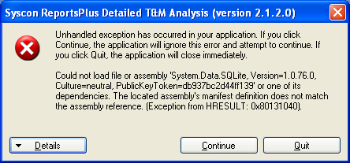

Other
- Tried to save the template – received message: You cannot change part of an array.
  - Will not allow me to save
  - Cannot quit Microsoft Excel.
  - Seems to happen after changing something in the template – that is in a column that is not to be modified.

Rules for transfer of job record changes:
- If there is an AR invoice record – cannot be changed
- If partial billing hours to a higher number then error
- If changed to status non-billable and there are no initials, then PM approval will be highlighted, but will still be imported.

